

Datacenter to Azure Migration

Prepared for *<Client Name>*



Assessment Report / Proposal

Prepared by

**Insert Name**

*<Solution Architect>*

*<Partner Name>*

*<Insert Date>*

Table of Contents

1 Introduction 3

2 Assessment 4

2.1 Business Overview 4

2.2 Business Case 5

2.3 AS- IS Architecture 5

2.4 Assessment Report 6

3 Proposal 7

3.1 Target State Architecture / Solution 8

4 Why Microsoft Azure 9

5 Execution Strategy 12

5.1 Migration Approach 13

5.1.1 Timelines 13

5.1.2 Project Deliverables 14

5.1.3 Resources 15

5.1.4 Project Risk Management 15

5.1.5 Dependencies 15

5.1.6 Governance 16

6 Expected Results 17

6.1 Financial Benefits 17

6.2 Technical Benefits 17

6.3 Other Benefits 17

7 Costs / Pricing 18

8 Assumptions 19

9 Conclusion 20

10 Next Steps 21

1. Introduction

The cloud helps transform your business, giving you competitive advantage by enabling you to more freely innovate. Having a reliable partner to support your cloud journey can help you realize this potential and focus your resources on business growth.

*<Partner Name>* offers *<Solution and/or Services>* support across the Microsoft *<Service, Solution or Product>*, helping *<Clients Company>* update your business and accelerate the value of your on-premises and cloud-based software investments. Tailored to your unique business priorities, we deliver proactive and reactive services that enable you to minimize risk, reduce downtime, and lower support costs. Through our partnership with Microsoft, *<Partner Name>* specializes in migrating workloads to Azure from a variety of platforms such as Hyper-V, VMware, and other public cloud providers, utilizing both Microsoft’s native tools and 3rd party solutions.

The purpose of this document is based on a follow-up from the assessments, workshops and interviews that was recently delivered on *<Clients Company>* infrastructure as part of the requirements gathering for the migration to Microsoft Azure Cloud Offering. It includes key findings, identified actions items with owners, specific next steps and timelines of execution. *<Partner Name>* believes we have a greater understanding of the scope and complexity associated with this effort and believe that this proposal and proposed solution reflect that understanding.

*<Partner Name>* can assist in the acceleration of implementation by utilizing prior project success and experience gained through similar engagements. Our team can provide technical, architectural, and overall project leadership expertise throughout the effort.

While this proposal is not meant to constitute a formal offer, acceptance, or contract, this proposal is furnished with the expectation that *<Partner Name>* would have the opportunity to provide the services specified in this proposal under a mutually agreed set of terms and conditions. In the event that *<Partner Name>* is selected to provide the products or services contemplated by this proposal, *<Partner Name>* will negotiate in good faith with *<Clients Company>* to finalize any appropriate agreements not already in place.

1. Assessment
   1. Business Overview

The *<Clients Company>* cloud strategy was provided in the presentation *<Business Owner>.*

|  |  |
| --- | --- |
|  | [Include the key cloud strategy outcomes that covers the problem and the key theme around business outcomes. Restate the client’s needs as determined as part of the RFP, SOW, POC, etc.] |

*<Sample of business overview>*

|  |
| --- |
| Business Overview |
| * *<Description of Business objective/s>* |

|  |  |  |  |  |
| --- | --- | --- | --- | --- |
| Business Goals |  | Success Metrics/KPI |  | Activities to achieve business goals |
| 1. |  |  |  |  |
| 2. |  |  |  |  |

|  |
| --- |
| Overview of Proposed Scenario: |
| * Target Audience * Requirements * Proposals |

* 1. Business Case

*<Partner Name>* shared the business case approach and the calculation model on premise services as well as services in Azure.

|  |  |
| --- | --- |
|  | [Include the key cloud business case outcomes that covers the metrics, success criteria and the key theme around business outcomes. Restate the client’s needs as determined as part of the RFP, SOW, POC, etc. your understanding of the client’s needs and specific issues to be addressed.] |

* 1. Assessment Report

|  |  |
| --- | --- |
|  | [Include the key findings based on the current architecture supplied by the assessments conducted with the relevant teams. Include all requirements and dependencies like networking, security, management, operations, infrastructure, and all requirements needed to for future state architecture.] |

*<Insert the scope, assessment methodology and the assessment report from the assessment tools used (Azure Migrate, Microsoft Deployment Planner, Cloudamize, third party tools, etc).>*

1. Proposal

|  |  |
| --- | --- |
|  | [Provide background information, including a brief background on your company and describe how your capabilities and proposed solution align with the client’s goals for the project, including how your qualifications can uniquely address the current opportunity.  Show your understanding of the benefits the client can expect. For example, describe the risks--what might be lost--if appropriate action is not taken and compare this to the benefits they can achieve with a positive course of action. If applicable, identify potential areas of concern for the client and how you can address them. Such items may be fundamental issues that appear trivial, but are often overlooked by competing proposals.] |

*<Client Name>* is a Microsoft partner. Through this partnership we can leverage Microsoft’s resources, tools and training to offer you excellent professional services matched with Microsoft’s enterprise grade cloud services…. *<continue>.*

* 1. Target State Architecture / Solution

|  |  |
| --- | --- |
|  | [Include future state architecture and recommendations that lead to your proposed solution. Summarize what you’re proposing to do and how you’re going to meet the goals. You’ll be able to expand on the details within the ‘Our Proposal’ section.] |

The target service architecture is:

Example: Insert high-level or key diagrams, inventories, etc. *<See Sample Below>*



Examples: Insert a detailed / low level explanation of solution and rational

1. Why Microsoft Azure

Microsoft Azure is a world leader in cloud computing and offers the best-of-breed IaaS, PaaS, and SaaS services.

Azure’s global reach along with its enterprise grade security, services, and availability SLAs, ensure that your applications and services offer excellent performance and world class customer experience.

**Azure:**

1. Offers consumption-based pricing, you only pay for what you use. Flexibility is key, and now with Reserved Instances and Hybrid Use, Azure can offer substantial savings over on-premise and other public cloud providers.
2. Accelerates app innovation through rapid app development and agility in the cloud. Elastic scaling based upon your applications need for performance and PaaS services allow you to concentrate on your application code and business.
3. Delivers integrated data and intelligence—data for rich insights to intelligence embedded within apps.
4. Is open and flexible, where you can use the tools and technologies you already have and want to use. Supporting both Windows and Linux workloads and associated CICD tools, Azure is suitable for almost all workloads.
5. Is trusted to protect your business assets. As more customers expect digital experiences, they expect the data they share with an organization to be protected.

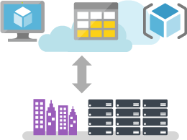

*Optimize your existing assets by taking a hybrid approach to the cloud. Azure offers hybrid consistency everywhere—in application development, security and management, identity management, and across the data platform. This helps reduce the risk and cost of a hybrid cloud environment by enabling a common set of skills and offering portability of applications and workloads.*

*Develop and build the way you want in Azure, with your choice of tools, applications, and frameworks, like Jenkins and Chef. As a leading open source contributor on GitHub, Microsoft actively supports multiple open source community projects—such as Kubernetes, fluentd, and Helm—and has a unique partnership with Red Hat to offer coordinated, multi-lingual support across multiple products.*

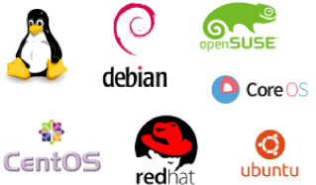

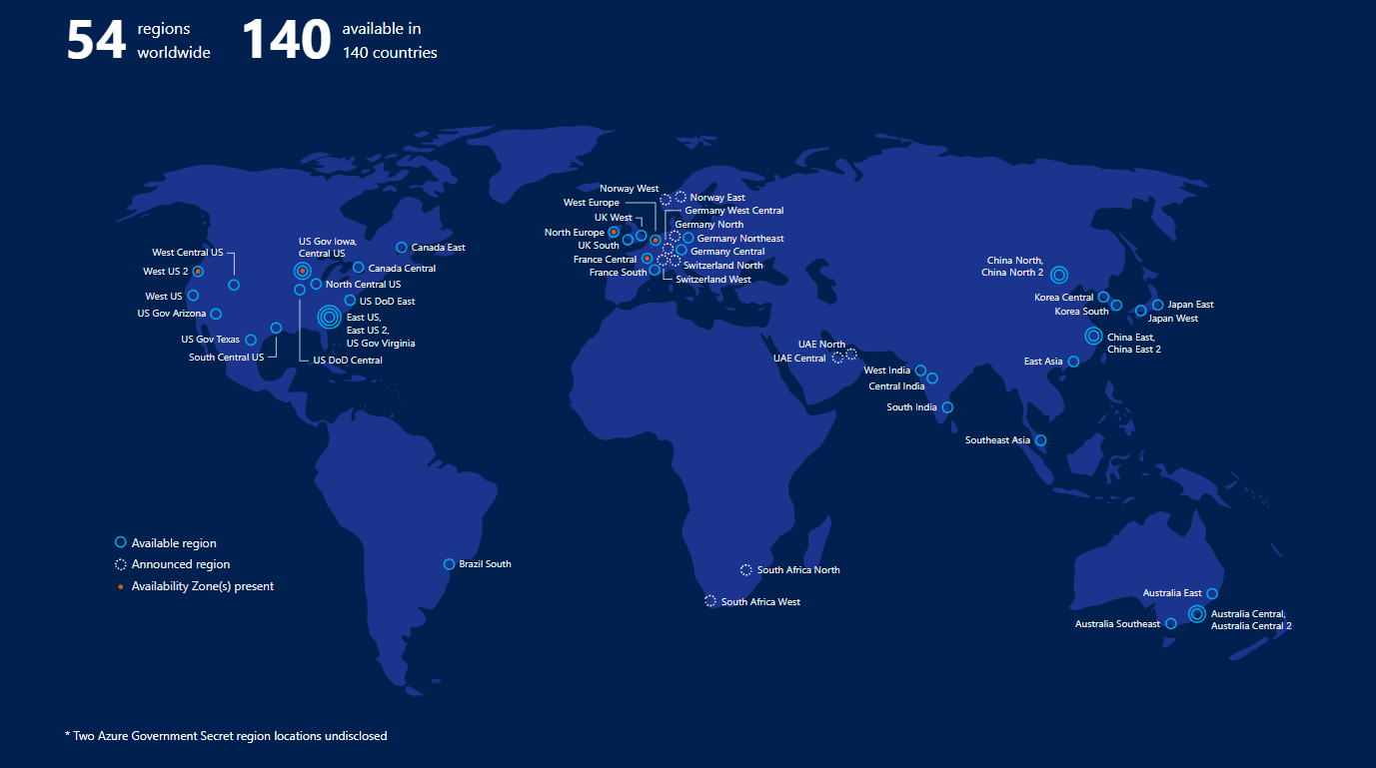

*Achieve global scale with 42 announced Azure regions—more than any other cloud provider. Azure’s priority on geographic expansion means you can choose the datacenter and region that’s right for you and your customers, with the performance and support you need, where you need it*

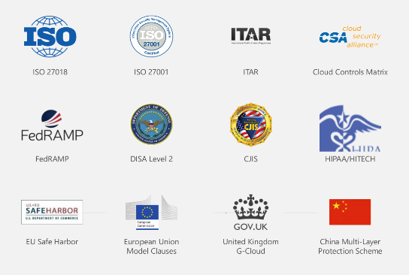

*Azure was the first major cloud provider to contractually commit to the requirements of the General Data Protection Regulation (GDPR). To protect your organization, Azure embeds security, privacy, and compliance into its development methodology, and has been recognized as the most trusted cloud for U.S. government institutions, earning a FedRAMP High authorization that covers 18 Azure services.*

1. Expected Results

|  |  |
| --- | --- |
|  | *[Describe the results expected from the project and how your approach will achieve those results.]* |

We expect our proposed solution to <Client Name>’s requirements to provide the following results:

* 1. Financial Benefits
* *<Result #1: Brief description of desired result mapped to customers business case>*
* *<Result #2: Brief description of desired result mapped to customers business case>*
* *<Result #3: Brief description of desired result mapped to customers business case>*
  1. Technical Benefits
* *<Result #1: Brief description of desired result mapped to customers business case>*
* *<Result #2: Brief description of desired result mapped to customers business case>*
* *<Result #3: Brief description of desired result mapped to customers business case>*
  1. Other Benefits
* *<Result #1: Brief description of desired result mapped to customers business case>*
* *<Result #2: Brief description of desired result mapped to customers business case>*
* *<Result #3: Brief description of desired result mapped to customers business case>*

1. Costs / Pricing

|  |  |
| --- | --- |
|  | *[Insert exported pricing from the tool used (Azure Calculator, 3rd party tool, in-house, etc.) including Microsoft Azure and professional/managed services costs. The below table is a basic example.]* |

The following table details the pricing for delivery of the services outlined in this proposal. This pricing is valid for <## days> from the date of this proposal:

|  |  |
| --- | --- |
| Services Cost <Category #1> | Price (One-off of monthly) |
| <Item Description> | <$0,000.00> |
| Total Services <Category #1> Costs | <$0,000.00> |
| **Azure Services <Category #2>** |  |
| <Item Description> |  |
| Total Services <Category #1> Costs | <$0,000.00> |
| **Additional Services <Category #3>** |  |
| <Item Description> |  |
| Total Services <Category #3> Costs | <$0,000.00> |
| Total | <$0,000.00> |

*<Sample> Disclaimer: The prices listed in the preceding table are an estimate for the services discussed. This summary is not a warranty of final price. Estimates are subject to change if project specifications are changed or costs for outsourced services change. Cloud based services are charged based on consumption and are therefore variable depending on usage, we have taken this in to account and have provided pricing based on our expertise and experience.

1. Assumptions

The proposed solution is based on the follow assumptions:

* <Assumption #1: Brief description of the assumption>
* <Assumption #2: Brief description of the assumption>
* <Assumption #3: Brief description of the assumption>

1. Conclusion

|  |  |
| --- | --- |
|  | [Close out the proposal with a statement that demonstrates your concern for the client and their needs, your expertise, and your willingness to help them solve the issues in question. Include any expected next steps and note the ways they can get in touch with you.] |

*<Partner Name>* looks forward to working with *<Client Name>* and supporting your efforts to migrate to cloud based services. *<Partner Name>* is confident that we can meet the challenges ahead, and stand ready to partner with you in delivering effective cloud based solutions

If you have questions on this proposal, feel free to contact *<Name>* at your convenience by email at *<Email address>* or by phone at *<Telephone>.* *<Partner Name>* will follow up with regards to next steps and discuss the proposal.

Thank you for your consideration,

*<Name>  
<Title>*